**41633 - Innovation Product Development**

**Business Pitch Deck**



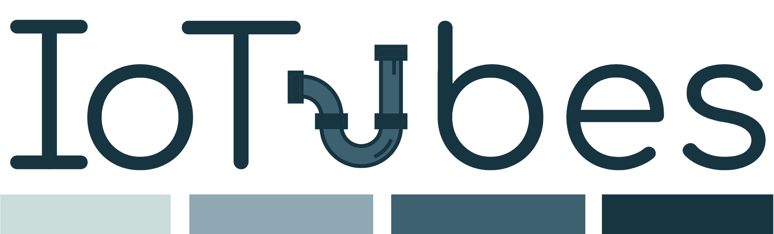

**Team 32**

Christopher Wolfgang Wild s180026

Jakub Brzosko s161116

Manuel Montoya Catala s162706

Maria Katsimitsi s171869

Mathias Hald (CBS-maha16bf)

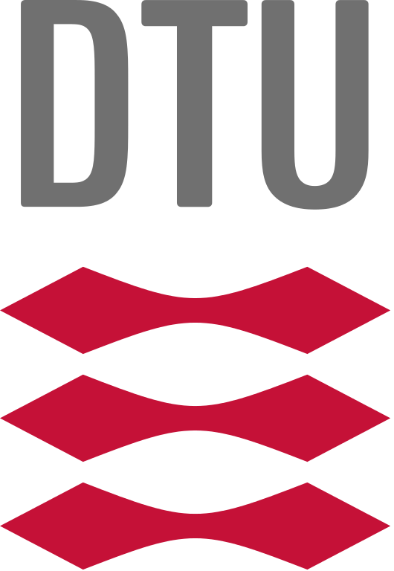

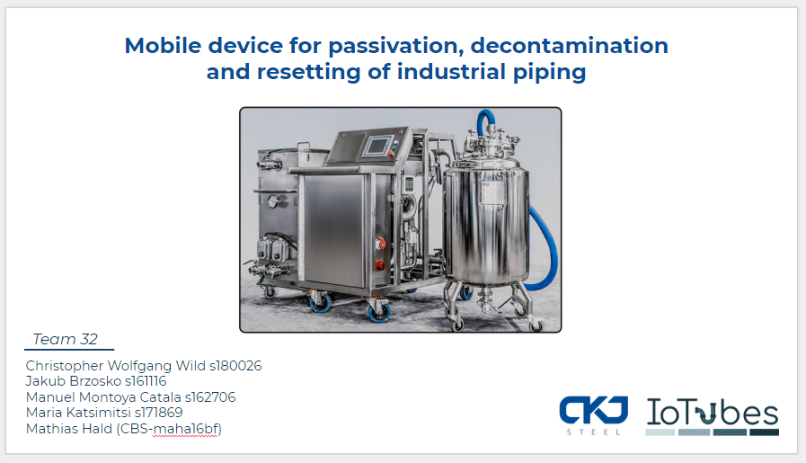

We are IoTubes - A group of 5 students, that dream big and aim high. Our idea is to improve cleaning processes in manufacturing of pharmaceuticals, beverages and food. Diversity is our asset - we all come from different countries and study lines, what allows us to look at the given issue from various perspectives and propose non-obvious solutions. Our group include engineering professionals, and down-to-earth business specialists, as well as more of artistic, design-focused minds.

Past couple of months have been a very busy and interesting period - pharmaceuticals manufacturing is quite a specific field of industry, that none of us had any prior experience with. We had to quickly catch up with learning it, as well as understand value proposed by solution developed by CKJ Steel. But that was just a beginning. We continued with positioning ourselves in the market, trying to determine pains that we could solve, key features that we should focus on, build our pricing and business model and much more tasks that every startup encounters on their journey. We have dedicated hundreds of working hours, send lots of emails, met, interviewed and discussed with tenths of people just for one purpose: assure that our project is reliable, attractive for customers, and feasible to be realised. Let us invite you to our short overview of our adventure!

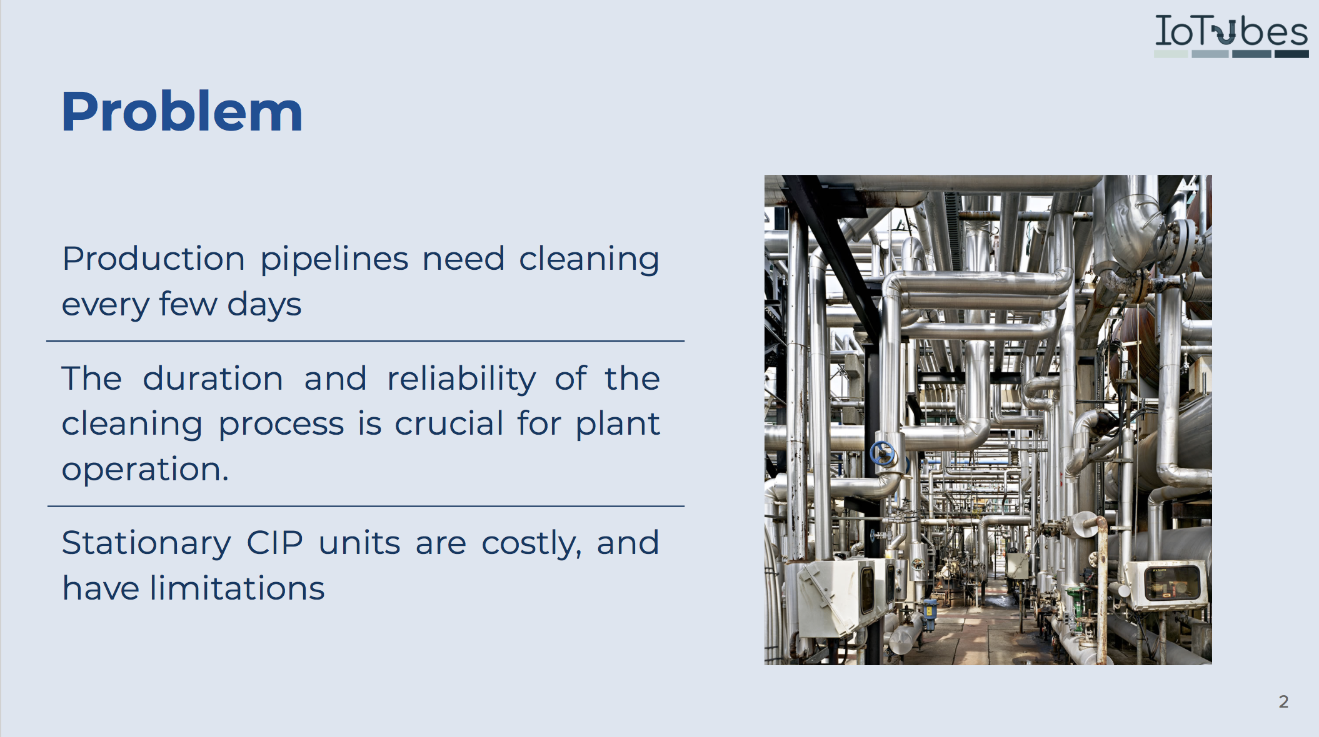

The problem that we address is, at a first glance, pretty straightforward: Medicaments need to be manufactured. There are factories doing so. Every factory has at least one piping system and containers, used to store, mix and process ingredients. Every time the recipe that the piping system elaborates is changed, and before one can start creating different product, the mentioned piping system needs to be completely changed and sterilised. It is obvious that the different batches of products should not be mixed. What is unique about pharmaceutical industry is: The cleaning standards are very high. As one can easily imagine, in some other industries, a little mixture between the different batches can be acceptable, but in the pharmaceutical industry, adding some antibiotic in an insulin might be very dangerous, if not deadly.

Therefore, the cleaning procedures have to assure, with no doubts, that all the leftovers have been erased. But that is not all. As some of the chemicals might potentially react with the piping material itself, before every batch it is required to passivate the inside of pipes and tanks - it means to create a protective layer, that is chemically passive, and will not react with the mixture inside. Given the variety of chemicals being used, cleaning procedures need to be universal. Furthermore, every procedure has to be FDA (Food and Drug administration) approved before it can be introduced. Such an approval is very costly and time consuming, what imposes thoughtful design of procedures.

Last but not least, cleaning has to happen within a piping structure that is fully assembled, with minimal number of cleaning-specific changes and adjustments - like in every business, time is money. It means, that access to and measuring status of part somewhere in the middle of the system is difficult, if not impossible. Therefore, on has to find other way of assuring that the system is clean.

One of the most used processes is pretty straightforward - one choses a reactive liquid, which is able to dissolve leftovers - acid or base - and then circulate it within the system, controlling parameters such as temperature, pressure and flow. The process can consist of many steps, with different liquids, being the last one to rinse the system clean with water.

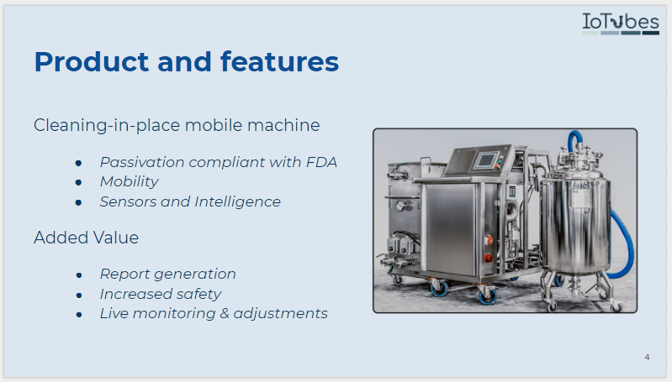

One of the most common solutions to clean piping in pharma industry are stationary Cleaning in Place devices. They are built together with the piping itself, and often they are capable of serving only one pipeline. Moreover, the vast majority of CIP’s operating now don’t provide any control or data on the process itself - they have a hardcoded routine to follow.

The product we propose performs the same type of cleaning process. The device consists of two carriages - one of them is a container for the liquids, usually an acid and a base, that can be warmed up to the required temperature, and the other one is a pump with the needed sensors such as flow meter, temperature sensor, and pressure sensor. Both of the carriages are relatively small and they can fit through the normal size doors so the machine can be easily transported to the place where it is needed. It has universal valves, which means it can be easily connected to input and output of the majority of piping systems, to create closed circuit. Given that cleaning process takes place every couple of days, in the plant with couple of pipings it would be possible to schedule everything that one cleaning unit could maintain couple of manufacturing pipelines.

Furthermore, our proposition includes some additional intelligence and sensors, such as pushbuttons assuring that the lid of the liquid tank is properly closed, preventing any spilling of the acid. Parameters of the process are continuously monitored to assure that every minute of the process happened as planned, and in case of any accident (leak of liquid, major rapid contamination) immediate action can be undertaken. After the cleaning process has ended, report of desired format can be automatically printed, with all the required information, or even uploaded to company’s database. This process is now done manually, which requires extra human power, and is prone to mistakes and inconsistencies.

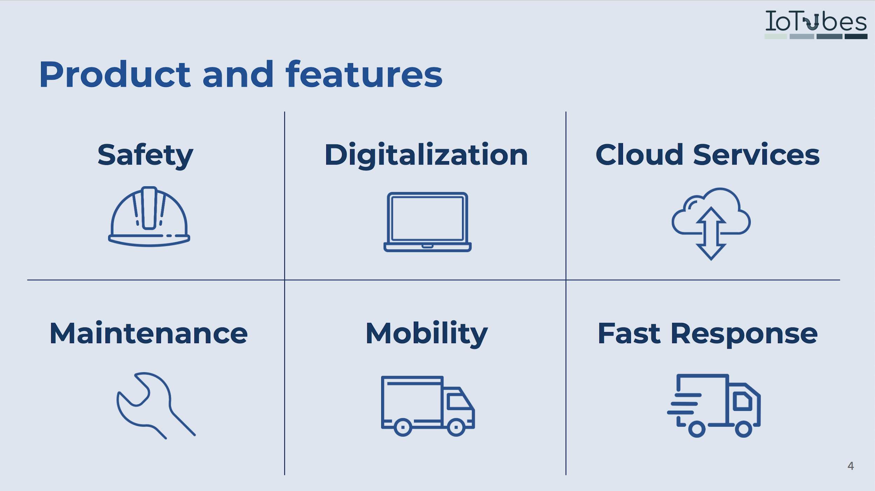

Key features that our solution provide are:

* **Safety safety and safety**: Our highly trained staff and digital safety measures will lower the risk of any accident which would damage the pipes, the workers or contamine the product.
* **Digitalization**: Automatic reports fed with data from the sensors of the machine.
* **Monitoring + Cloud**: Implementing a system where we sample the values of the sensors contentiously and we send them to a device connected through the internet which will display them. This is useful for:
  + Real time monitoring of the process to detect a failure as early as possible.
  + Over time the performance of the machine could vary. Obtaining this data would allows us to quantify it and determine when something is going wrong.
* **Maintenance:** Renting our machine will imply full service and maintenance during the rental period.
* **Free acid:** While renting our machine, one does not need to worry about liquids to be used, as we provide them.
* **Mobility**: Our machine fits through a standard door which allows it to access most of the places in a company.
* **Short-Response time:** Due to the lower dimensions of the machine, the time to load it and take it to company is short, so we can adres emergency requests.

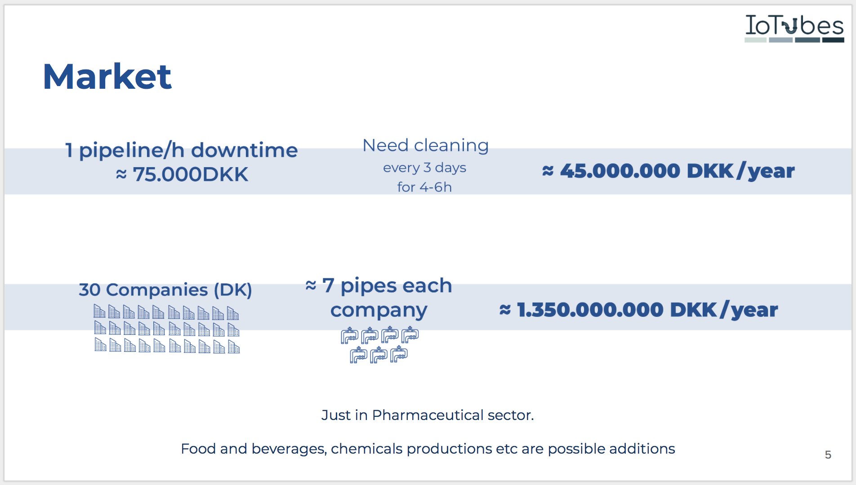

As the pharmaceutical industry is closed and hermetic, it is not possible to find many informations about prices, spendings or any quantitative details about company’s work and performance, other than very general ones. In order to approximate our market size, we had to make some assumptions. The information we got from one of the engineers working with manufacturing was, that by the rule of thumb, one hour of downtime of their pipelines is worth 10.000 euro, which is about 75.000 DKK. That was the starting point of our calculations.

From other source we have been told, that on average pipelines are cleaned twice per week, and it takes 4-6 hours (of course, it is highly dependable on size of the system and specifications of the substance produced). With this information we can calculate the total amount of hours spent within a year, and the total worth of downtime per piping system per year - estimated to be around 45 million DKK.

As mentioned, this industry is pretty closed up, therefore it is not simple to tell for sure how many pharmaceutical manufacturing plants are there in Denmark, and how many pipelines do they have. Though, from informations we gathered we can assume there are 30 manufacturing entities in Denmark, having an average 7 pipelines each. Under such assumptions, cleaning downtime is worth more than one billion, 1.000.000.000 DKK per year. Of course, it does not mean that one can make this amount of money per year.

First of all, we used the price of an hour of downtime, not price of an hour of cleaning - price of cleaning is still to be decided. Secondly, some of those companies have their own systems, and will be not interested in outsourcing. It was just an indication of the order of magnitude. As we were informed, competitors price is 50.000 dkk for whole day of cleaning, what gives price of approximately 6.000 dkk per hour. It can be treated as reference point.

One last thing worth mentioning is, that upper mentioned calculation were conducted only for pharma industry. Potential application in food and drink or chemical industry would mean extending the market.

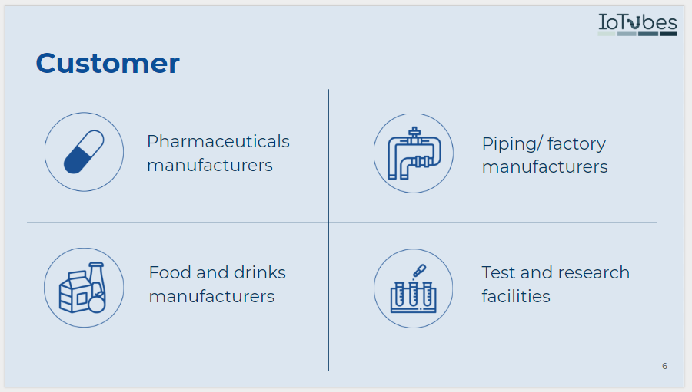

As mentioned already, the main customer sector are Pharmaceutical Manufacturers which require cleaning procedures compliant with FDA standards, which impose very high degree of cleaning and repeatability. Those are the stakeholders that might be the most interested in the ongoing monitoring and reporting features provided by our machine, as for every batch of products, they need to prepare and store documentation.

We can extend to other areas where it is not cost effective to have a in-place CIP or the monitoring degree of the cleaning process is not very high. Such potential client could be piping / factory manufactures, as they are required to clean their built products before delivery. Those clients would appreciate mobility and universality of our solution, as it can be easily moved to the pipings they built, used for cleaning and taken back.

We have also recognised, that not all the piping systems are used for continuous manufacturing of different products. There is a number of test and research facilities, that produce small batches, irregularly and are restructured from time to time in order to test different possibilities and setups. The mobility and flexibility of our solution would be a big advantage here.

Last but not least, there is number of other industries, that manufacture their products within pipings. Their requirements regarding cleanliness might not be as high as for medical graded applications, but applying higher standards is not harmful. All the mentioned benefits of our solution remains valid, and might be of interest within other industries.

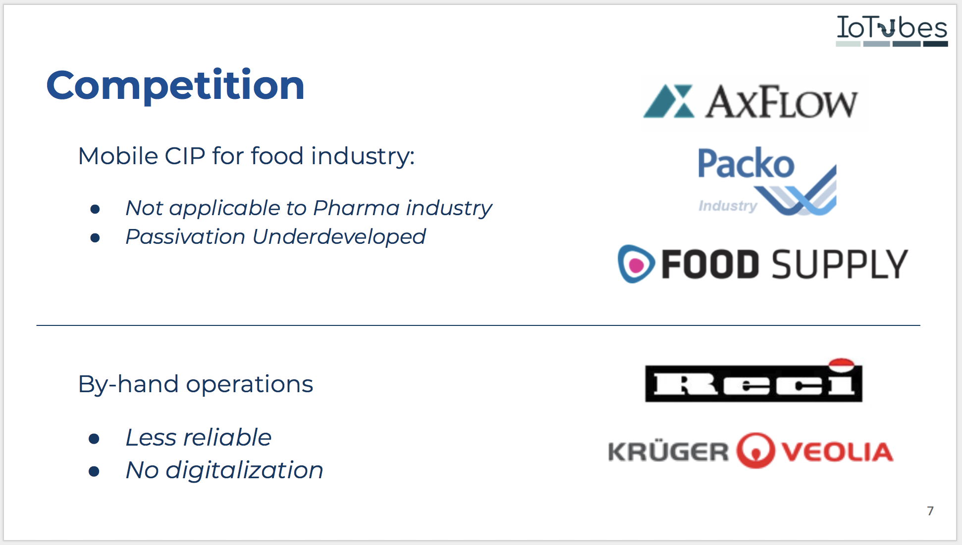

As one can imagine, we are not the first ones ever to propose some non-stationary mean of cleaning pipelines. There are competitors within this market, offering a similar solutions, or services serving substitutionary purpose.

The first group of competitors are companies such as axFlow, Packo and Food Supply. Those companies manufacture mobile Cleaning in Place devices for food industry, which are somehow similar to what we propose. Those devices consist of a big compartment with water, a small compartment with detergent, a heater and a pump. The main difference being, that those devices are not suitable for strong chemicals such as acids and bases, meaning that this first group can not comply with FDA standards for the pharmaceutical industry, and they do not allow passivation of piping systems. Last but not least, those companies don’t provide incorporated digitalisation, what means that they require significant level of human operation, and are prone to human mistakes and subjectivism.

On the other hand it is worth mentioning, that those companies have more experience in designing and manufacturing such devices. They are confident enough, to propose designing devices tailored to personal need of customers. Those companies can be our competitors in other industries, but not so much in the pharmaceutical one, due to their mentioned inability to deal with strong chemicals.

Another group of competitors are companies such as Reci and Kruger. Those companies offer a service of cleaning which is conducted by hand by their technicians. Such an approach causes human error to be introduced, as technicians are responsible for proper proportions of the cleaning liquid, and control of the parameters of cleaning. As one can imagine, humans are less suitable for long and repeatable tasks than machines, and quality of such tasks tends to be better when operated by machines. Even though they might be cheaper due to lack of big initial investment, the quality of production is of high importance in the industry, while price is secondary.

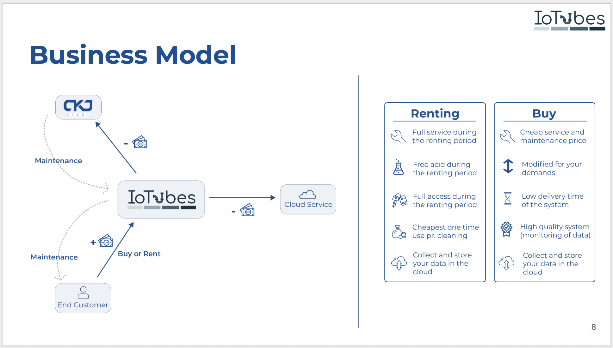

Our Business Model is simple:

We have a partnership with CKJ, company that manufactures basic version of the device, consisting of fluid compartment, and pump compartment with basic sensors in which:

We buy the basic version of the CIP device.

We will provide a service in our value proposition where the customers can get included free maintenance in the renting package we will just put a markup on the subscription and it will be CKJ that take the responsible for the maintenance.

After buying the machine from CKJ we will include more sensors to the machine, such as ph meter, safety push buttons etc. and build the infrastructure to monitor the process, gather the data and upload it into the cloud service that we implemented.

We charge Customers for either buying or renting the advanced version of the device. We handle free yearly free acid and an yearly included maintenance subscription within renting package. If the customers are one time buyers of the machine we will be the provider for CKJ.

They can use the Machine and the IT Services as they like. We offer them support with:

Maintenance of the machine: We will be the one that guarantees proper functioning of the machine. CKJ Steel would be our subcontractor, maintaining the basic version, responsible for hardware, while we will assure proper functioning of software part.

We will also support our clients with operating the cloud service: How to Visualize the Cleaning Processes, Machines, how to generate reports, upload files etc.

Our cash flow will be generated by reselling the machine with some added features as described above to companies within the pharma industry. Our cost of buying the machine will be covered due to the low delivery time on 14 days from CKJ, thereby we will be able to get positive cash flow before handed by achieve the payment from our end customers before we should pay CKJ.

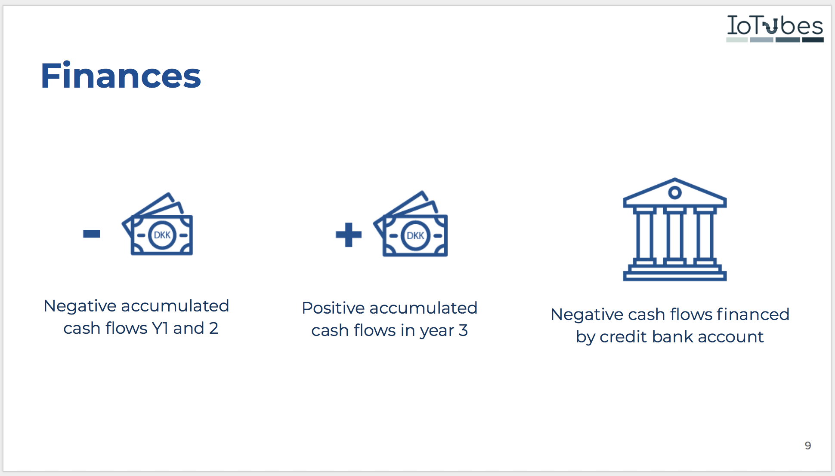

Our financial model relay on that we are selling more machines in the beginning and renting lesser, otherwise we will get a liquidity problem of financing the machines for renting. As we described in the business model our cost will be covered to CKJ by reselling the machine to our customers. Our cost due to buying the machine will be around DKK. 1.000.000 and the re-selling price will be 1.500.000 the CIP system has a utility time of 5 years. Thereby we need to buy new machines every 5 th years because of it will depreciate. But on the other hand, our one time buying customers also need to renew their CIP systems every 5 th year, and thereby this will be a regenerated cash flow stream from the customer.

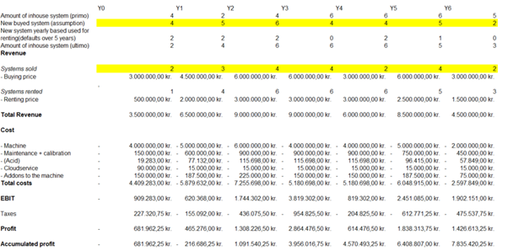

As stated in the modified income statement Y1 DKK. - 681.962 will generate a negative cash flow and and Y2 will generate a positive cash though the accumulated profit will still be negative. Due to conservative assumptions the company will generate negative accumulated cash flow in the two first accounting years, while we have assumed that half of the system belongs to rented systems and the other half to resell systems.

Normally an investor onboard, will be the best solution while we already have a great balanced team, and furthermore CKJ as a key partner with directly contacts into the pharma industry, it will probably fit better to finance the negative cash flows from y1 and y2 with a credit account.

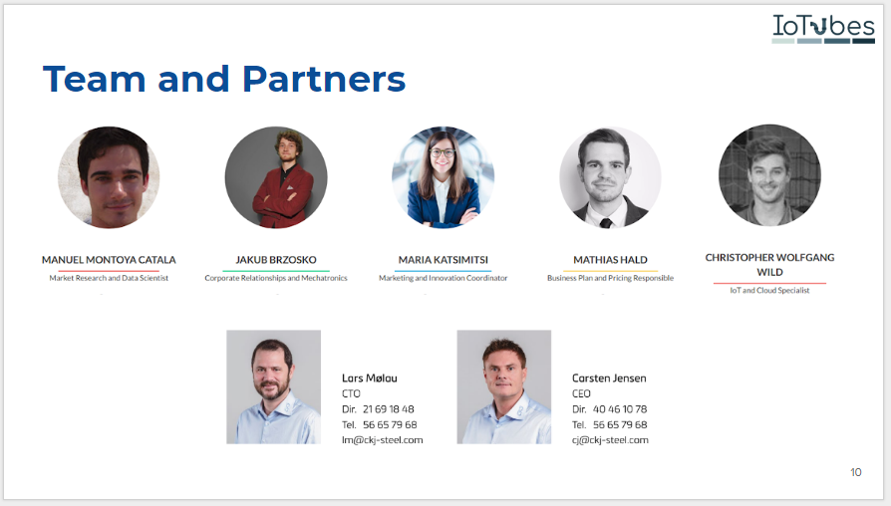

The IoTubes team is composed by 5 students, 4 of which are engineers from DTU and a businessman from CBS. Together we gather all the necessary technical and professional, hard and soft skill required for building a startup as IoTubes.

We have Manuel Polla, who is a Data Scientist, and takes care of proper processing of the data gathered and establishing cloud service along with Christopher. Jakub assures flawless cooperation of our solution with the existing device, and reaches out to people that might be relevant for our startup. Mathies is our market and business specialist, securing our financial and economic stability. Maria is our designer, shaping rough technical content into the form understandable for human beings and keeping an eye on our PR.

Of course we could not have made it without or partners from CKJ Carsten and Lars who supported us and gave us a great starting point for the project. They introduced us to the industry, and helped understanding it’s backbones .

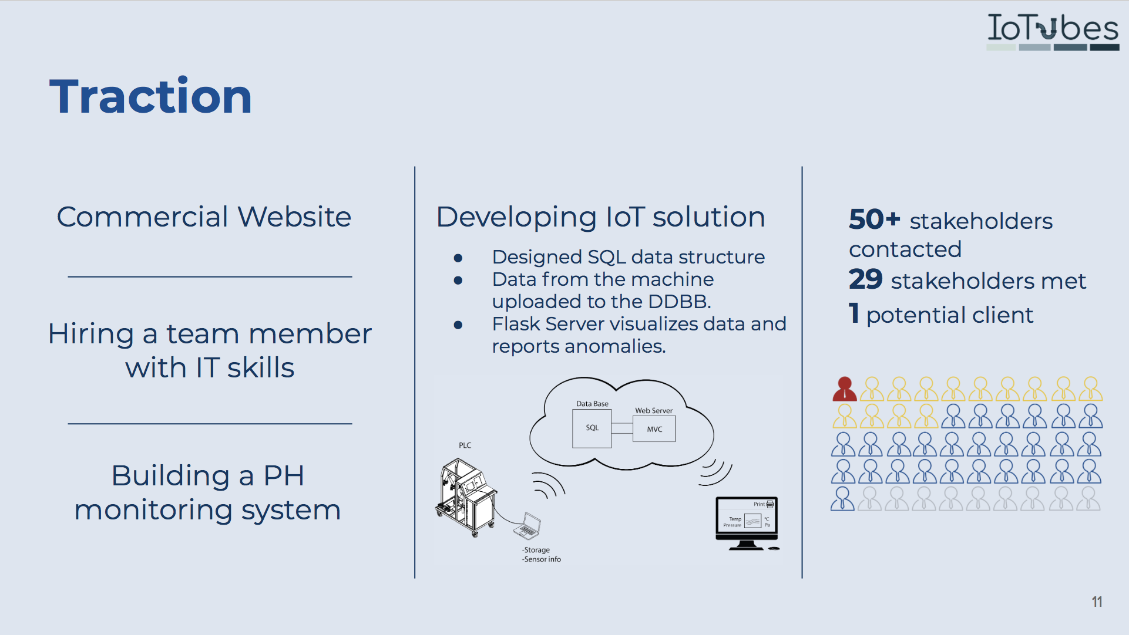

We tackled the project from different angles:

* Since promotion is essential for introducing a new product, We created a commercial website iotubes.dk with a modern Look&Feel in order to attract possible customers.
* We wanted to add digitalization to the machine so we created a flyer and post in several channels to get a new member with IT skills. Our strategy turned out to be successful, as we got some applications among which we chose Christopher, and invited to be our new team member.
* Since we could not have access to the machine to get the data, we bought Arduino and PH sensor (which the original machine does not have) to build a mock up system that provides us with same type of data as the real one, so we can validate our ideas and develop cloud software immediately.
* We developed an IoT solution in Python Flask + SQL to upload the data to the Cloud and further process it and visualize it.
* Since we were not provided with any previous market research, we wanted to really improve on that and we contacted 50+ stakeholders, and met Face to Face with 29 of them, out of which we have a potential client, who expressed interest in buying our device - one of the test plants established by Novo Nordisk.

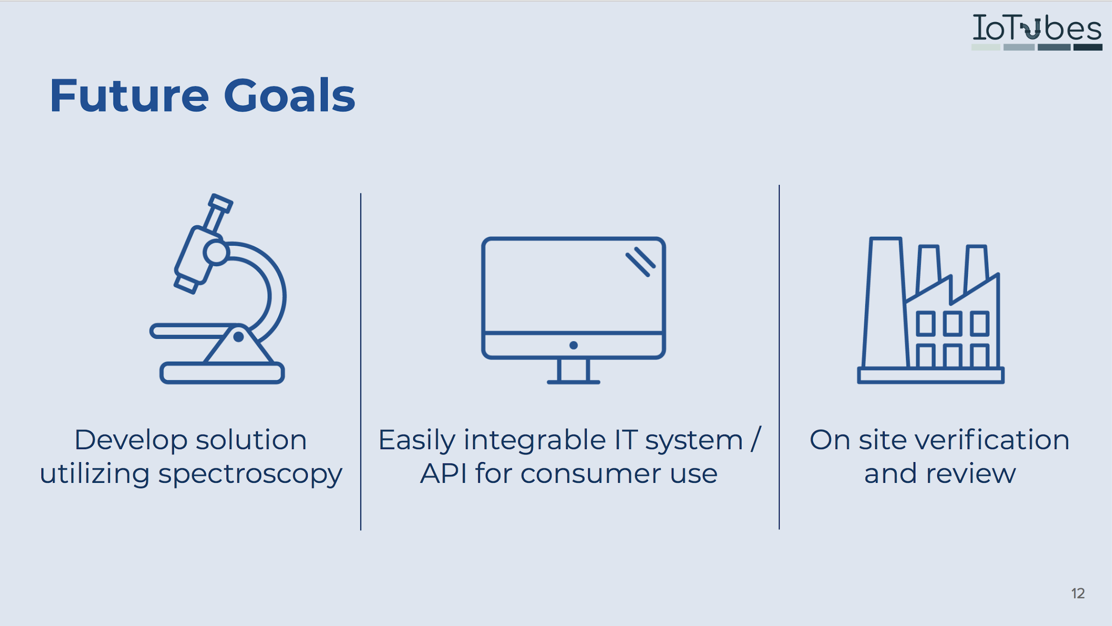

Of course within the time boundaries, budget and human resources that we had in this course we could not develop everything we would like to, especially keeping in mind the size and the price of the device we worked with. We managed to accomplish some of our goals and ideas, but of course there are still improvements to be developed. Some of the most valuable improvements we would like to create are:

* Implementing spectrometer within the machine. All the measurements of contamination of liquid that are being conducted now are not direct, meaning we don't measure contamination as such, but it’s effect on pH of liquid, or it’s electrical conductivity. With spectrometer it would be possible to directly measure amount of particles per million, allowing way higher accuracy and recognition. Having such a measurement, we could provide a brand new service for a new market, which could be validation of the existing cleaning procedures, and checking if those can be shortened. There is one company so far providing similar service, which proves it being feasible. Keeping in mind cost of an hour of downtime, being able to shorten the cleaning procedures even half an hour would bring significant benefit. We see it as a very promising direction of our development.
* Creation a webapp for using the cloud services of the machine. Why ? Because it is 2018. We would also like to provide our clients with an option to integrate our solution with their existing IT systems, via dedicated API or other means.
* Performing on site tests and verification of the machine. It would allow us to tailor our design to actual user needs and demands, as well as simply check whether our solution is working in the real-life conditions.

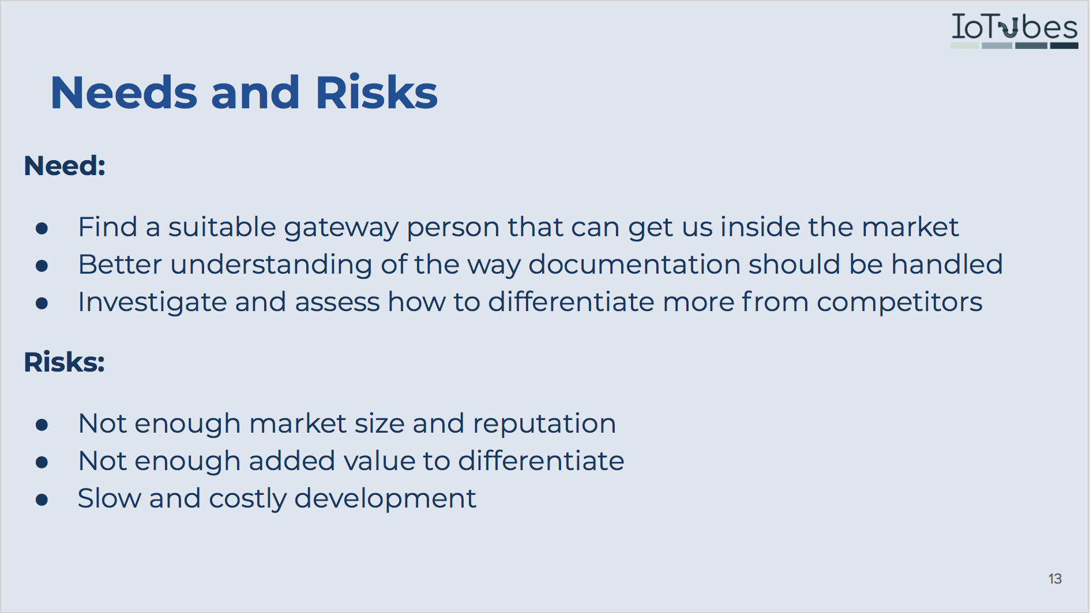

NEEDS:

* One of the key struggles that we had is finding a proper entry point in the market, a person that knows the right people and could present our solution to the right stakeholders. When we contacted the big players such as Novo Nordisk, it was hard to be heard or trigger an actual action from them in the right direction. As this branch of the industry is mainly populated by big companies, in which taking any decision takes a lot of time, interaction with them is very time consuming.
* Report generation and how these are compliant with FDA standards is also an area that we could not find that much information for and will influence the way the files are created, managed and stored. Even though we will have to assure certain level of flexibility, so particular clients can adjust the solution for themselves, outline of the report has to be created.
* We saw some competitors already acting in markets close to ours, so we need to think on better ways to differentiate from them in the future. We have tried reaching out to them, to understand their business model and technical possibilities, but it was not very successful.

RISKS:

* The market is very specific and has safety as main keyword, what makes it quite an expensive but very clustered market where reputation and trust are more important than modern technologies and innovation.
* The development of the IoT infrastructure and web apps can be slow and costly.
* Even though our improvements provide added value, it may not be recognised by the final customer, what might make our proposition not that different and interesting in their eyes.

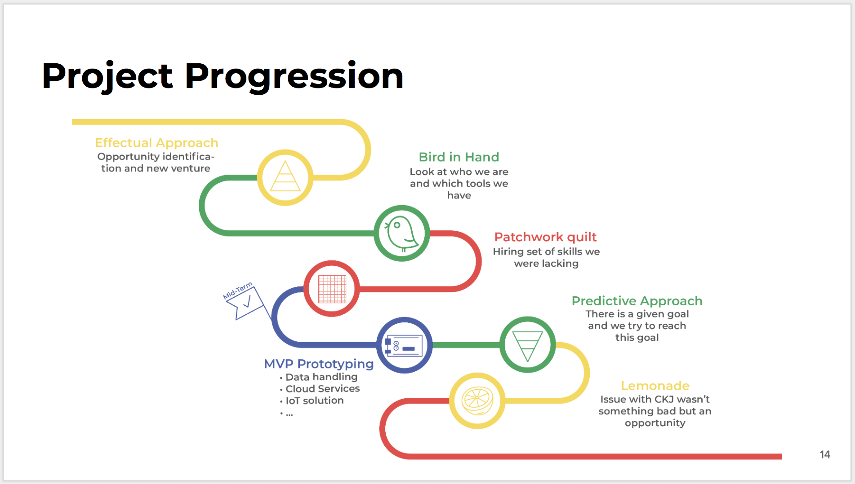

In the beginning, we started to work on redrawing the given problem and searching for new opportunities within the problem area. After a while, we had the first replies regarding the meetings from a variety of companies. Through these meetings, we were able to understand "who we are" and "what we know". That was the moment we have realised, that we miss some skills in our team, and we decided to hire. That helped us to move to the next phase. After the first milestone, we started to work on the MVP prototyping and more specifically on data handling, cloud services, and IoT solution. While we were developing the MVP prototyping, we entered a new phase, the Predictive Approach phase. The future for us was more predictable and as a result, we tried from the means that we had to achieve our goals. Finally, after a meeting with Biopro, an issue with the CKJ arose. That led us to the opportunity to change the way we were contacting companies. More specifically, instead of saying that we are working with CKJ, we are saying that we are buying the piece of the equipment from CKJ and we built our cloud and IoT system on it. Even though it was a challenge, forcing us to take a step back, we managed to redesign our cooperation and continue on with new partnership.